Octose® 060 Specifications
Flat tops, Curtain Siders, Refrigerated Vans

Due to the manufacturing process these
are not exact measurements and should
be used as a guide only.

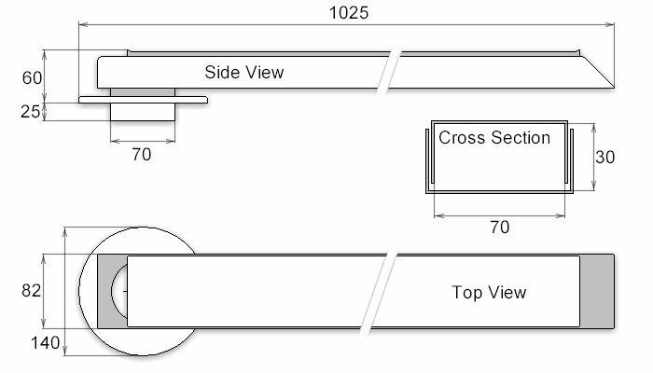

All measurements are in millimetres (mm).



