Octose® 080 Specifications
Semi Tippers, Side Tippers, Floats, Car Carriers with Hydraulics

Due to the manufacturing process these
are not exact measurements and should
be used as a guide only.

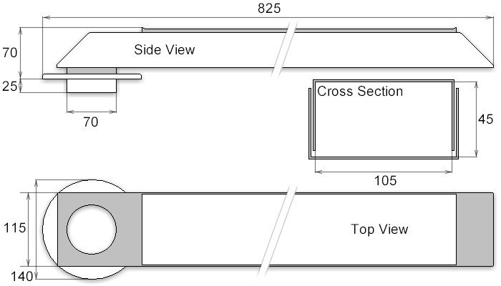

All measurements are in millimetres (mm).



